TAREA: COEVALUACIÓN FORMAL SIERRA QUINCENA 6.2
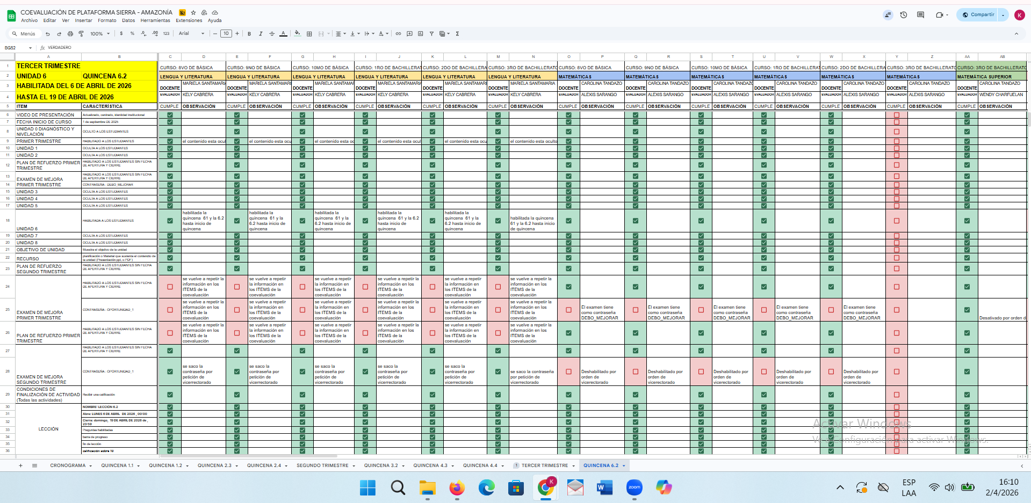
https://docs.google.com/spreadsheets/d/1uU1eSmVp6_E6KbLhKBVe3-uhHZwP7aVdADLLVAhubLY/edit?gid=1552905307#gid=1552905307

